A Systematic literature Review- “Effects of Hybrid-Agile approaches and methods on the quality of software.”
Muhammad Shoaib Farooq¹, Esha Fatima Tahir¹

¹Department of Department of Computer Science, University of Management and Technology, Lahore, Punjab, Pakistan
*Corresponding author: Shoaib.farooq@umt.edu.pk

ABSTRACT Software developers have a reputation of embracing new advancements and practices based on their novelties or empirical indications of their potential. We are conducting an SLR, this paper describes the findings of SLR aimed at determining what combinations of agile practices, and methodologies are utilized in hybrid approaches, as well as how the usage of hybrid and agile approaches affects quality of software. In the last 5 years there are more than 3800 original scientific published were considered in the review, from which 14 papers are yielded on the topic. There are six distinct agile methodologies that have been observed effecting the quality of software, as well as Twenty-one agile practices that have an effect on twenty-five different quality attributes of software.
KEYWORDS: Agile approaches, agile methods, hybrid-agile Approaches, software quality

JOURNAL INFO
HISTORY: Received: Accepted: Published:..

INTRODUCTION
The pressure for software companies to provide high-quality products on time and on a tight budget has become more difficult in recent years. Software processes assist them in achieving this goal, as well as gaining satisfaction of customers, gaining a competitive advantage, and meeting the financial demands of their shareholders. We are seeing a lot more variance now that the agile approach has spread to larger enterprises in more industries. Granted, from XP to Scrum to Kanban to Continuous Delivery, we are used to a diversity of frameworks, techniques, and procedures in use. However, we have been hearing more and more about "Hybrid" approaches recently.
The methodology of agile is strategy of managing projects that organizes the project into phases. Moreover, it demands the continual involvement of the stakeholder along with continual improvement at every stage. Once the project has begun, teams go through a planning process, conducting, and evaluation. Hybrid Agile is a process that mixes agile and non-agile approaches. Hybrid approach can consist of a thorough requirements process usually accompanied by incremental delivery sprints[1]. Because of the restrictive nature of traditional frameworks and the rise in the complex nature of projects, more and more firms are adopting agile techniques. Agile approaches are being used in software development as a new process. They are primarily used to shorten the SDLC while maintaining quality. The application of agile approaches to any project with the goal of quality assurance is necessary. To minimize production costs, many software development companies are now adopting agile approaches in their projects. Companies that develop software to produce high-quality services and products use the most agile methods[2]. XP, scrum and lean software development were combined to create a new approach (hybrid agile software development). The strengths of the existing agile methods, such as XP, Scrum, and lean software development, are combined in the hybrid agile paradigm. Furthermore, the approach provides better results in terms of quality assurance[3].
The goal of this research is to locate scientific papers that explore various combinations of agile methodologies and their effect on software quality. Secondly, in order to define the quality factors that is impacted by the agile practices.
The rest of the study is categorized as follows: second section offers the most relevant literatures on the area, third section proposes the research methodology, and 4rth section presents research findings, which include identified hybrid-agile methodologies and the impact of agile practices on quality attributes, which are then analyzed and discussed. The conclusion is discussed in Section 5.

- RELATED WORK
Today, the adoption of agile approaches for project management is increasing, with seventy-one percent of organizations reporting that for their projects they use the approaches of agile, and one in every 5 projects employing a hybrid approach, combining techniques from agile and non-agile approach. The goal of this study is to uncover scientific papers that look into different combinations of agile approaches and how they affect quality of software.
We do know, however, that there are a variety of SLRs on the subject of agile development and software quality.
The number of SLRs covering the issue of agile software development is increasing. They address a variety of topics related to agile development. The benefits and limitations of agile and hybrid methodologies are represented in studies. They noted that subjects and research disciplines such as hybrid agile in large-scale setups could benefit from additional secondary and primary research[4]. In (2017) a research by[5], on the other hand, focus their research on identifying obstacles in the engineering of quality requirements in agile projects. They identified 12 quality-related issues and provided 13 solutions for addressing quality needs in agile projects. In addition,[6], as well as [7], looked at two other aspects that influence software quality; those are testing and agile development. Different testing techniques in agile development can have a significant impact on software quality, according to[6], while [7] used Systematic literature review to present aspects of software quality applied to the agile software development process, and their work identified 118 critical success factors, 137 agile practices, 70 quality models and 102 metrics. For example, in 2016, a SLR conducted on issues in agile software development. Their research uncovered 30 problems in agile software development, all of which have a major impact on quality[8].
- RESEARCH METHODOLOGY
The systematic literature review has been chosen as a research strategy to investigate the effect of hybrid-agile approaches on the quality of software. SLR is a technique that helps in distinguishing, assessing and deciphering accessible research pertinent to an expressed research question. In 2007, [9] stated an SLR has three phases shown in figure1.
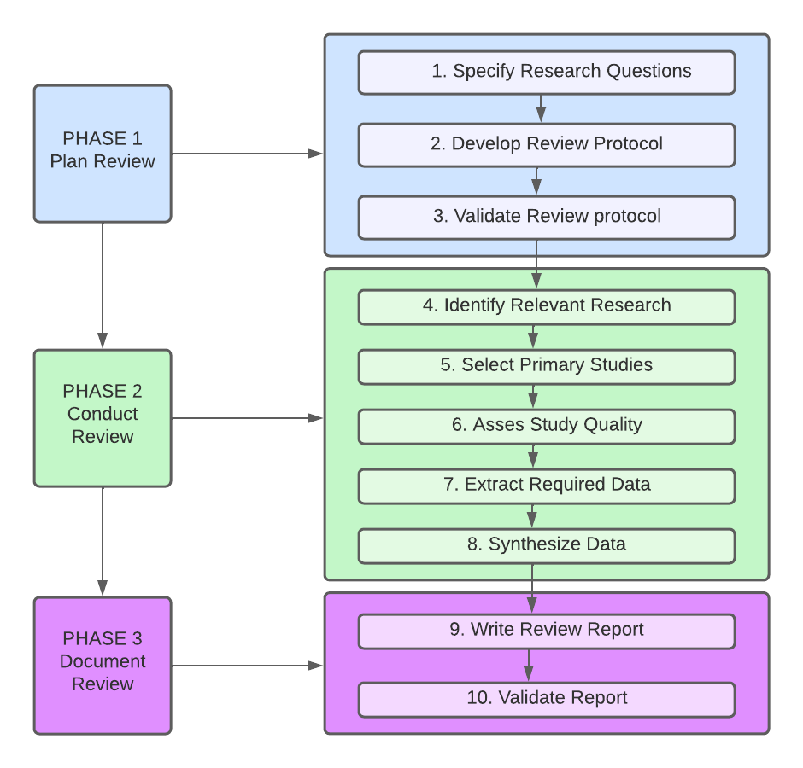
FIGURE 1. Kitchenham proposed the SLR procedure. The figure's style has been altered somewhat from Brereton.

The research procedure for this SLR is depicted in Figure 1. There are three levels to this reflective review procedure: 1) Review Planning 2) Conducting a review process 3) Document Review.
- Review Planning: This is the first phase of an SLR. In 2007, [10] stated that in this phase we really want to determine the research question, foster a review convention and approve the review convention. The purpose of this research is to analyze existing studies and their finding to give a layout of effects of Hybrid-Agile approaches and methods on the quality of software.
- Research Objective
The following are the prime objectives of this research:
RO1: The main goal of this research is to provide the quality software.
RO2: Through which combination of agile approaches we can improve the quality of software.
RO3: Identifying the practices, which is having impact on quality.
- RESEARCH QUESTIONS
Two research questions have been developed.

TABLE I. Research Question & motivation
 | Research Question | Major Motivation
RQ1 | What are the combinations of agile methods are used in hybrid approaches that has an effect on the quality of software? | To identify the hybrid-agile approaches to improve the quality.
RQ2 | Which agile practices influences the quality attributes? | Refine the quality attributes by using agile practices.

- SEARCH STRING
With the definition of the research questions, I picked out the search string to gather the start set of studies. The search was directed through Google Scholar than in other notable databases, for example, Science Direct, IEEE-xplore, and Wiley on the web or Springer to limit inclination. To guarantee the pertinence of the chose articles, the string of question was limited to run against the paper titles and keywords as below.
((Hybrid OR agile) AND (“software development”) AND (“quality of software” OR “software quality” OR “system quality”))

- Inclusion Criteria

The requirements for inclusion criterion are as follows:
- Studies are published after 2015
- Studies are in English.
- Studies that are published in conference or a journal.
- Quality Assessment
To filter the remaining articles, we created quality assessment questions, as shown in Table 2. All responses must be affirmative in accordance with study to proceed to the phase of data extraction.
TABLE II. Quality Assessment Questions.
Is the study primarily concerned with the effect of the agile-hybrid methodology on software quality? | YES/NO
Is the study able to explain why hybrid or agile approaches are used? | YES/NO
Is there any information in the study about the factors that influence software quality? | YES/NO
Is there a link between the research questions and the findings? | YES/NO

- Conducting a review process
This systematic literature review is supplemental to existing studies and gives the contributions to the individuals who are keen on Effects of Hybrid-Agile approaches and methods on the quality of software. I identified 3869 studies from 2015-2021.Then I picked 14 essential studies as shown in Figure 2 that fulfill the criteria that I set for quality appraisal phase.

FIGURE 2. Selected studies ratio.

14 papers were used in the data extraction phase after passing all of the inclusion and quality assessment criteria. In order to address research questions, studies were examined. From the studies, the title, kind of study, and significant findings and conclusions were gathered.
- Discussion and Results

The fourteen key publications were examined in this section using the research questions listed in Table I. The facts gleaned through the study of the chosen papers were discussed using questions for evaluating fragmentary information.
Assessment of RQ1. What are the combinations of agile methods are used in hybrid approaches that has an effect on the quality of software?
Many firms nowadays aspire to develop systems in a short amount of time and at a low cost [11]. They utilize agile approaches as a result they enable flexibility, allow modifications at any time, and are contributed to greater software quality [12] [11]. Despite the use of innovative approaches, a large number of IT initiatives fail. They went over budget, produced poor quality, and missed deadlines. In addition, rework due to quality flaws wastes a lot of time[13]. The focus of this discussion is on the relationship between the methods of Hybrid-agile and software quality.
Papers I have examined have a diverse perspective on software's quality. Many researchers define quality as satisfying the demands and expectations of customers, whereas [12] defines the 3 forms of the software quality: design quality, performance quality and adoption quality. Quality attributes can be broken down by these characteristics.
As previously stated, enhancements in software quality can be accomplished by adopting and adapting various methodologies into hybrid-agile models. Some studies, for example, look at the process of testing as a method of promoting software quality. According to [14], the main struggle in testing of software in agile methods is the lack of time and focus on the testing process, but they are attempting to demonstrate with this study that assigning more resources to testing can improve quality of software without sacrificing other agile method benefits. They discussed the benefits of using agile methodology to establish Dynamic Quality Control. This combination of agile approach and Dynamic Quality Control assists in the detection of hidden vulnerabilities. [15] Also suggested a framework with one of the goals being to detect more defects in initial testing cycles. The proposed metrics framework was shown to be beneficial in enhancing software quality, according to the findings. Furthermore, as one of the Rapid Software Development models, the Q-Rapids quality model allows for faster problem detection and might be used in enterprises to compare system quality[16]. Some other instance is indeed the method of agile development that is Test-driven development (TDD), which, when combined with Iterative Test-Last development (ITL), contributes in software quality improvement [17].
To increase software quality, some hybrid models combine the best of both methods. Scrum, Lean Software Development and Extreme Programming are combined in the hybrid agile model [3] .Other writers allude to the same agile composition but do not use the same terminology [12], [13] [18]. It’s a method of agile development that prioritizes quality. The most significant benefit of this strategy is the relatively leas error rate, which leads to high-quality software. In following Table III, it is a list of hybrid-Agile methodologies that have been explored in this literature.
TABLE III. Summary of Q1
REF NO | Hybrid-Agile approaches
[3]  [12]  [13]  [18] | Scrum-lean-XP software development
[14] | Dynamic Quality Control with Agile
[16] | Rapid software development (Q-Rapids)
[17] | (TDD)(ITL)
[15]  [19] | Agile-Waterfall
[20] | Safe-SDLC
Assessment of RQ2. Which agile practices influences the quality attributes?
Several papers evaluating the effects of agile practices on quality attributes have been uncovered in relation to our second research question. Process Automation, for example, has been demonstrated in multiple studies to have a significant effect on quality of software. [21] Assessed the effects of Continuous Integration on software quality, and found that using continuous integration improves software quality significantly. Additionally, having a sprint release provides for faster feedback, which may be leveraged to enhance quality of the software. Teams must discover technologies for enhancing and automating the process of deployment in order to accomplish regular releases [13]. When a process is automated, it would be more suitable to accomplish releases on a regular basis. Sprint is an important feature of agile development that is also linked to software quality [19], albeit the authors do not specify the quality attributes they are alluding to.[22], on the other hand, tailor iterative approaches to attain quality. They established a sprint format in which clients or user groups may provide review.
Furthermore, in every sprint, quality is a key factor in which teams of agile must create quality requirements [20]. They can use these criteria to track quality improvement from sprint to sprint. In addition, every iteration is focused on uncovering defects. They place a premium on detecting faults during internal testing cycles. As a result, the team will be able to rectify them sooner and enhance quality of the software.
21 agile practices were shown to have a substantial effect on quality of software in the literature. The quality attributes and practices that they effect are listed in the Table IV. 25 quality attributes that have been found. Many of them were being affected by other agile methods and are listed again in the table.
TABLE IV Summary of RQ2
REF NO | Agile practices | Quality attribute
[3] | Requirement specification  Planning  Development  Testing  Validation  Deployment | Accessibility, scalability, adaptability, performance, portability, and interpretability
[11] | Continuous integration, system testing, and workshop | Consistency, reusability, verifiability, effectiveness, integrity, and formal verification
[13] | Sprint  Releasing each sprint  Test automation | Functionality  Testability  Effectiveness
[14] | Testing  Review meeting of daily defects | Testability  Effectiveness
[18] | User story, Accepted User stories, access the efficiency, Sprints | Accessibility, Functionality, Stability, and Manageability
[19] | Sprint | Utmost quality
[20] | Test cycles, releasing cycle | Yearly rate of failures, number of flaws
[21] | Continuous Integration | Way to develop,  Bugs that have been introduced, time to release, Quality control,  Documentation, management development, and a cost model
[22] | Iterative approach, Prototyping, Usability testing, Test automation | Verification Effectiveness, testability

CONCLUSION
This paper gives an overview of hybrid-agile approaches and agile practices that have been shown to improve software quality. I found 14 publications addressing this topic in our systematic literature review of over 3800 unique studies, which resulted in the exploration of six combinations of agile methodologies that are stated to have an effect on quality of software. I also found twenty-one agile practices that have a substantial effect on up to 25 quality attributes of software. This study focuses solely on scientific evidence, excluding other forms of existing literature such as "grey" literature, dissertations, reports, and online postings, among others. However, this research indicates that methods of agile in combined effect with other agile principles can significantly improve quality of the software.
REFERENCES

[1] N. Prenner, C. Unger-Windeler, and K. Schneider, “Goals and challenges in hybrid software development approaches,” J. Softw. Evol. Process, vol. 33, no. 11, pp. 1–25, 2021, doi: 10.1002/smr.2382.
[2] P. Abrahamsson, M. A. Babar, and P. Kruchten, “Agility and architecture: Can they coexist?,” IEEE Softw., vol. 27, no. 2, pp. 16–22, 2010, doi: 10.1109/MS.2010.36.
[3] L. Neelu and D. Kavitha, “Estimation of software quality parameters for hybrid agile process model,” SN Appl. Sci., vol. 3, no. 3, pp. 1–11, 2021, doi: 10.1007/s42452-021-04305-0.
[4] R. Hoda, N. Salleh, J. Grundy, and H. M. Tee, “Systematic literature reviews in agile software development: A tertiary study,” Inf. Softw. Technol., vol. 85, pp. 60–70, 2017, doi: 10.1016/j.infsof.2017.01.007.
[5] J. Lockerbie, N. Maiden, C. Williams, and L. Chase, “A requirements traceability approach to support mission assurance and configurability in the military,” Lect. Notes Comput. Sci. (including Subser. Lect. Notes Artif. Intell. Lect. Notes Bioinformatics), vol. 10153 LNCS, pp. 308–323, 2017, doi: 10.1007/978-3-319-54045-0_22.
[6] M. Thangiah and S. Basri, “A preliminary analysis of various testing techniques in Agile development - A systematic literature review,” 2016 3rd Int. Conf. Comput. Inf. Sci. ICCOINS 2016 - Proc., pp. 600–605, 2016, doi: 10.1109/ICCOINS.2016.7783283.
[7] G. Arcos-Medina and D. Mauricio, Aspects of software quality applied to the process of agile software development: a systematic literature review, vol. 10, no. 5. Springer India, 2019.
[8] T. Hacaloglu and O. Demirors, “Challenges of using software size in agile software development: A systematic literature review,” CEUR Workshop Proc., vol. 2207, pp. 109–122, 2018.
[9] B. Kitchenham, “Procedures for Performing Systematic Reviews, Version 1.0,” Empir. Softw. Eng., vol. 33, no. 2004, pp. 1–26, 2004.
[10] P. Brereton, B. A. Kitchenham, D. Budgen, M. Turner, and M. Khalil, “Lessons from applying the systematic literature review process within the software engineering domain,” J. Syst. Softw., vol. 80, no. 4, pp. 571–583, 2007, doi: 10.1016/j.jss.2006.07.009.
[11] M. A. Subih et al., “Comparison of agile method and scrum method with software quality affecting factors,” Int. J. Adv. Comput. Sci. Appl., vol. 10, no. 5, pp. 531–535, 2019, doi: 10.14569/ijacsa.2019.0100569.
[12] G. Arcos-Medina and D. Mauricio, “Identifying factors influencing on agile practices for software development,” J. Inf. Organ. Sci., vol. 44, no. 1, pp. 1–31, 2020, doi: 10.31341/jios.44.1.1.
[13] G. Kasims, “Applying lean to improve quality in software development projects,” ACM Int. Conf. Proceeding Ser., pp. 130–134, 2018, doi: 10.1145/3278252.3278254.
[14] R. Tommy, M. Mhaisekar, S. Kallepally, L. Varghese, S. Ahmed, and M. D. Somaraju, “Dynamic quality control in agile methodology for improving the quality,” 2015 IEEE Int. Conf. Comput. Graph. Vis. Inf. Secur. CGVIS 2015, pp. 233–236, 2016, doi: 10.1109/CGVIS.2015.7449927.
[15] O. Edvhg et al., “% Dfn Wr % Dvlfv ± 5Hghilqlqj 4Xdolw \ 0Hdvxuhphqw Iru + \ Eulg,” [Online]. Available: https://ieeexplore.ieee.org/document/8987494/keywords#keywords.
[16] S. Martínez-Fernández, A. Jedlitschka, L. Guzmán, and A. M. Vollmer, “A quality model for actionable analytics in rapid software development,” Proc. - 44th Euromicro Conf. Softw. Eng. Adv. Appl. SEAA 2018, no. 732253, pp. 370–377, 2018, doi: 10.1109/SEAA.2018.00067.
[17] A. Santos et al., “A family of experiments on test-driven development,” Empir. Softw. Eng., vol. 26, no. 3, 2021, doi: 10.1007/s10664-020-09895-8.
[18] P. Jain, A. Sharma, and L. Ahuja, “The Impact of Agile Software Development Process on the Quality of Software Product,” 2018 7th Int. Conf. Reliab. Infocom Technol. Optim. Trends Futur. Dir. ICRITO 2018, pp. 812–815, 2018, doi: 10.1109/ICRITO.2018.8748529.
[19] M. Bianchi, G. Marzi, and M. Guerini, “Agile, Stage-Gate and their combination: Exploring how they relate to performance in software development,” J. Bus. Res., vol. 110, no. May 2017, pp. 538–553, 2020, doi: 10.1016/j.jbusres.2018.05.003.
[20] S. Pradhan and V. Nanniyur, “Large scale quality transformation in hybrid development organizations – A case study,” J. Syst. Softw., vol. 171, p. 110836, 2021, doi: 10.1016/j.jss.2020.110836.
[21] S. Hamdan and S. Alramouni, “A Quality Framework for Software Continuous Integration,” Procedia Manuf., vol. 3, no. Ahfe 2015, pp. 2019–2025, 2015, doi: 10.1016/j.promfg.2015.07.249.
[22] V. Berg, J. Birkeland, A. Nguyen-Duc, I. O. Pappas, and L. Jaccheri, “Achieving agility and quality in product development - an empirical study of hardware startups,” J. Syst. Softw., vol. 167, 2020, doi: 10.1016/j.jss.2020.110599.

