

VFAST Transactions on Software Engineering
http://vfast.org/journals/index.php/VTSE@ 2022, ISSN(e): 2309-3978, ISSN(p): 2411-6246
Volume 10, Number 1, January-March 2022 pp:
(Page size: letter (8.5*11) double column siae width 3.38 and spacing 0.25)
ABSTRACT
Our economy is mostly based on agriculture. One of the difficult problems in the agriculture sector is crop yield predictions. Crop yield prediction using a machine learning algorithm with the help of IoT increases the production of wheat yield and improves the quality of yield. Today's low agricultural production is a problem for farmers. Low crop output is mainly caused by a lack of information regarding soil fertility and crop selection, and proper crop selection is the key to maximizing crop yield. One of the interesting agricultural research areas where deep learning (DL) algorithm concepts can be used is the identification of wheat disease from images. We consider two leaf diseases septoria and stripe rust and also take a healthy leaf and then do a comparison between the leaves using CNN. As a contribution, we developed a system ML with a neural network mobilenet and efficient net-b3 that detects wheat leaf disease and improves accuracy gradually. Moreover, we do a complete review of yield management in which IoT sensors are used with machine learning algorithms. This study aims to create a system that can correctly choose a crop for maximum yield utilizing IoT devices and machine learning (ML) algorithms. We achieve 97% accuracy using mobilenet which is better than the efficient net. The presented work also applied different image augmentation techniques to remove the problem of overfitting. The presented work is compared with the state-of-the-art method in terms of accuracy and precision score.

KEYWORDS: IoT, machine learning, disease detection, crop yield prediction, CNN, efficient net-b3, mobilenet

JOURNAL INFO
HISTORY: Received: Accepted: Published:
Wheat Disease Detection for Yield Management Using IoT and Deep Learning Techniques
SANA AKBAR¹, DR KHAWAJA TEHSEEN AHMA$D^{2}$, Mr. Muhammad Kamran Abid³
DR NAEEM ASLAM^{4,}

¹Department of computer science, university of NFC IET, Multan, Pakistan
²Department of computer science, Bahauddin Zakariya University, Multan 60800, Pakistan
³Department of computer science, university of NFC IET, Multan, Pakistan
⁴Department of computer science, university of NFC IET, Multan, Pakistan

INTRODUCTION

The population of the world is predicted to increase from 7 billion people in 2013 to around 10 billion people in 2050, extending the agricultural system under the condition of modest financial development[1]. Approximately 37.7% of the land surface is currently utilized for the cultivation of crops from job creation to social contribution. Agriculture contributes significantly to national income. It makes a substantial contribution part of the industrialized countries' economic success and contributes significantly to the economies of emerging countries. Agriculture has seen a tremendous increase in productivity. The population rate increasing continuously and it’s difficult to fulfill the demand of the population crop need. The delay between demand and food becomes most distinct and alarming over time. So, with the increase in population, it’s a need to make improvements and innovations in the agriculture sector. To increase the production in the agricultural industry many researchers and experts have suggested different and latest techniques as well as relevant use of technology. Literature predicts that there will be 9.8 billion people on the planet in 2050, an increase of about 25% from today's population. On the other hand, in developing nations, urban areas produce the majority of the crops, and by 2050, income levels will likewise rise from their current levels of the crop like soil moisture, PHP, weather conditions, water quality, and irrigation method. Sometimes the differentiation of characteristics of the same crop can also be measured in the same field due to soil type and weather conditions so there is a need to do a complete analysis of soil type and other factors that are necessary for increasing the yield production. There is a need to address these problems using technology. The technological process put great innovation in every field of life, including the cultural sector. In developing countries, farmers are using old fashion techniques so there is a need that farmers to visit the agricultural sectors which are using the latest techniques they get a better idea to increase the yield production of crops. For this, there is a need to boost the smart technologies system as most of the farmer’s time is spent monitoring and understanding the crop condition instead of doing the fieldwork. The wheat crop is the most important in Pakistan. Pakistan ranks in 6th position for wheat production and 8th position in terms of area but for yielding its ranking on 59th position. The total global production worldwide in 2020 of wheat was 760 million tons. Most of the wheat is produced in India china and Russia. According to research, almost 41% of wheat production is produced in these countries. Soil management is vital Issues to be able to be addressed to be able to understand the causes of declining plant yields. Many aspects affect wheat costs including; climate modification, yields, oil costs, lagged prices plus imports. Since whole wheat prices affect therefore many people, knowing how different aspects affect the global wheat market will be essential for policymakers[2]. In a wider sense, a much better understanding of the entire world wheat market will also help investors improve their earnings plus reduce expense risks. Water scarcity, late planting, and other factors all contribute to low average wheat yields[3]. Plant protection issues, low or uneven fertilizer use, aged production, and so on. Aphid attack, a lack of water, decreased fertilizer use, and excessive rainfall at the maturity stage, according to factors in the drop[4]. Punjab's wheat harvest Pakistan had 5300 m3 of water per capita available per year.
Convolutional neural network (CNN)-based artificial intelligence (AI) and machine learning (ML) research have recently attracted a lot of interest. CNN is used in a variety of applications, including image detection, image retrieval, and image classification because of its exceptional performance[4].
IoT with Deep learning has made a great revolution in the yield management of wheat crops and helps us a lot in the disease detection of wheat crops. So there is a need to do a lot of work with deep neural networks to improve our yield management of wheat crops.
Wheat yield can be improved by controlling the amount of water in the soil. Plant nutrient uptake is also heavily influenced by soil moisture. Deficit irrigation can enhance net financial returns and water utilization without compromising production. Deficit irrigation has benefits and drawbacks. It might improve water efficiency, but only if a specific amount of soil moisture is guaranteed. A crucial season-ending indicator known as yield accounts for the cumulative impact of weather and management decisions during the season[5].
It's tough to identify diseases in crop leaves. If detected early enough, related insects can be used to control the disease. A lack of primary nutrients can be detrimental to crops. The use of the proper nutrient is so essential. Farmers find it challenging to get data for their fields on environmental conditions, seasonal crop data, groundwater levels, soil nutrient levels, and water nutrient levels. Furthermore, they are having problems improving their selections in light of the available facts.
Diseases negatively affect crop productivity and reduce yields. Reduces diseases, including stripe rust, stem rust, and leaf rust might impact the quantity and quality of the yield in a study area. Additionally, manually identifying and interpreting wheat diseases takes time and effort. Currently, decisions regarding plants are primarily based on the level of domain expertise[6]. We deployed various deep learning models, such as mobilenet and , efficient net, to address these issues and detect wheat illness as early as possible.

Wheat disease types
- Stripe rust
- Septoria
- Bacterial leaf disease
- Black rust
- Brown rust
- Loose smut
- Powdery mildew
- Kernel bunt
In this, we discuss two types of wheat leaf disease septoria and stripe rust
This disease often referred to as Septoria leaf blotch, is brought on by Septoria tritici. On crop leftovers, the fungal pathogens overwinter and produce two different types of spores. Both are spread over large distances by wind and over small distances by rain splash. Warm, humid weather is favorable to the sickness. Additionally, seeds may carry the illness.
Small yellow to brown flecks first appear on leaves. These tumors sometimes have uneven, yellow-to-brown margins and brown-to-grey cores. This leaf disease can be distinguished from others by the tiny black dots that emerge in the infected areas and represent the pathogen's sporulation structures. On wheat and barley, S. nodorum also causes glume blotch. Septoria leaf blotch/spot reduces seed set and results in shriveled seeds, which reduces production

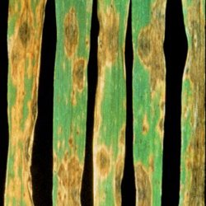

Figure 1: Septoria leaf disease

The most significant disease affecting wheat in Victoria is stripe rust, which can harm crops throughout the state and occurs in most seasons.
There have been three further significant introductions of wheat stripe rust into Australia since 1979 (2002, 2017, and 2018). Three of these incursions—from 1979, 2017, and 201,8—might have come from Europe, while the fourth, from 2002, may have come from North America. These introductions experience alterations throughout t time that boost their virulence (ability to attack more resistant kinds) and, in certain cases, cause them to supplant more established pathotypes. There will be a variety of pathotypes of stripe rust present in some seasons while only one pathotype will predominate in others. For instance, the University of Sydney found seven or so different strains of wheat stripe rust in eastern Australia in 2020. Early in the day is when stripe rust is easiest to spot.
Search for yellow stripes of pustules on the leaves, especially the older leaves down in the canopy. The yellow stain left by pustules, which are risen above the leaf surface, can be removed with ease using a white cloth or tissue. In regions with temperatures below 14°F without snow cover, the fungus that causes stripe rust does not easily overwinter. The fungus persists in regions where spores are blown, and when they land on leaves, they start new infections. Wet and chilly temperatures generally enhance disease growth. If the weather is good, the infection cycle will keep repeating, leading to secondary infections, and the disease's severity can swiftly approach epidemic levels.
Yellow rust, often known as stripe rust, is a fungal disease that affects plants and is brought on by Puccinia striiformis f. sp. tritici. The disease mostly affects leaves, although it can also harm glumes and awns. Infected "hot spots" are caused by this stage of the lifecycle and are visible in crops in the late winter and early spring.
Stripe rust spores can diffuse more readily and travel significantly farther in environments with lower relative humidity. This could lead to a consistent pattern of illness development starting in the middle of spring.
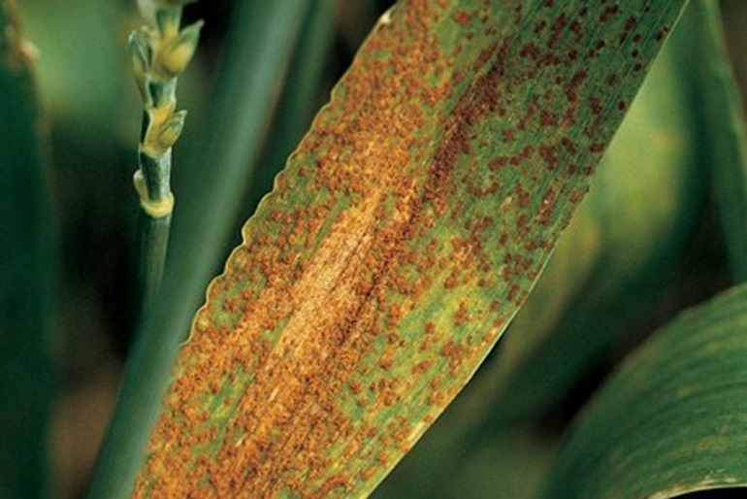

Figure 2: Stripe rust wheat leaf

Techniques for remote sensing can give producers final yield estimates and demonstrate variations in different fields. They are comparable in this regard to yield monitors mounted on combines, which are an important component of agricultural precision However, distant measurements differ in several ways that they can be used regularly throughout the season providing timely data on plant growth rates and control and responsiveness to changing weather conditions practices[7]. There are two techniques for employing remote control sensors for yield estimation. The first is a direct approach, in which where projections are entirely based on remote measurements.
The second is indirect, in which parameters are measured and mostly included in crop simulations on computers within-season calibration or growth and development model output (for example, biomass or GLAI) or in a user-to-change model beginning conditions or feedback loop procedure. Agricultural-related challenges such as crop storage, transportation considerations, and crop risk management effectively manage issues. Crop yield prediction is popular, and there are many tools available to help you do it right[8].
The tools can extract or mine meaningful information from datasets including relevant data such as rainfall. Temperature, evaporation, radiation, soil moisture, pesticides, fertilizer, area, and other factors are all taken into account. These tools can be used to make decisions in farming.
The accuracy of aggregate yield estimates made a year or more ahead determines whether a farm program succeeds or fails. Although it is clear that the trend in agricultural yields has been dramatically upward in recent years, there is considerable debate about the respective contributions of various technological advancements and weather to these yield increases.
An objective yield prediction technique necessitates not only a comparison of these components' respective influence on yields but also a projection of the future values that each factor is likely to reach[3].
By utilizing complex algorithms to analyze vast amounts of data, machine learning can assist in demystifying the hidden patterns in IoT data.
Novelties and contribution of our work is
- It performs in-depth analysis, gathers several photos of healthy and diseased wheat leaves, and compares both types of leaves
- A technique is introduced employing mobile net and efficient net that increase the outcome in terms of prectoder to achieve better-improved results.
- A rapid image retrieval system that is efficient in terms of storage, computation, and time is presented
The remainder of the piece is structured as follows. Section 2 presents the relevant research on CNN with machine learning and IoT. Section 3 presented the technique. The experimental results, which are shown with graphs and tables in Section 4, are also discussed. The conclusion of the method offered is discussed in Section 5.

RELATED WORK
For decisions, predicting the decisions is a crucial task for decision-makers at the national and regional levels. The farmer can grasp what kind of land is good for predicting wheat output with the use of machine learning algorithms.
There are different approaches to wheat yield prediction. In this review, we find out what has been done or which smart system has been invented for wheat yield management.
In [9] author discussed IoT-based smart farming techniques. The author also discusses unnamed aerial vehicles and robots which are used to collect data for harvesting, seedling, weed detection, and real-time livestock using IoT and machine learning. The main contribution of the author is the author uses 5G technology with high-speed data in developed countries. Although 5G technology gives high-speed information in developing countries, it’s most costly to use a sensor with 5G.
In [10] author discussed precision agriculture by applying machine learning algorithms using the internet of things. The author builds a model which collects real-time data from the sensor and applies a machine learning algorithm. author build a model for apple disease apple orchard in Kashmir valley. using author methodology, it gives real-time information about the disease but it only discusses the disease and ignores other parameters such as soil moisture and weather condition.
In [11] author discussed with machine learning. The author gives a general review of machine learning algorithms used with IoT. The author identifies soil properties using machine learning with IoT to improve yield management.
In [12] author used machine learning algorithms such as decision trees and MLP to improve crop prediction. The author develops a model that collects data from IoT sensors and applies a machine learning algorithm. The author discusses different parameters like humidity, soil, and temperature but the author ignores disease factors in the crop which is important in yield management.
In [13] author developed a model that uses a soil sensor, PIR sensor, temperature, and humidity sensor with an android app. using the app author collects real-time data. This project indicates that there is a great development in irrigation using it but it also has some disadvantages like the internet unavailability or any of the sensors is failed.
In [14]A researcher presented a framework for tracking and monitoring smart crops. Big data analytics, IoT cameras, smartphone apps, and sensors are all covered. The hardware consists of an Arduino Uno, multiple sensors, and a Wi-Fi module. The least amount of agricultural waste would be produced with this method, which would also result in the most effective use of energy. Although the author uses a better model still there is a need for Drone technology is being investigated as well. It will be possible to map fields in 3D and monitor crop production and life conditions by linking this technology to drones. With the aid of the GSM module and IoT SIM card on our laptops, we can connect the complete system to the Soracom Lagoon dashboard for an even more in-depth investigation.
In [15] The author developed an effective and precise method that can appropriately choose a crop for optimal yield using IoT devices and machine learning (ML) algorithms. When compared to manual laboratory testing procedures, which are prone to human mistakes, such a system is more trustworthy. In the agricultural arena, proper crop selection is a top priority. As a contribution, the author presents Smart Crop Selection (SCS), an ML-based model that is based on data from metrological and soil parameters.
In [16] Used IoT devices and machine learning (ML) algorithms, the author created an efficient and accurate system that can correctly select a crop for maximum production. When compared to manual laboratory testing procedures, which are prone to human mistakes, such a system is more trustworthy. In the agricultural arena, proper crop selection is a top priority. As a contribution, the author presents Smart Crop Selection (SCS), an ML-based model which is based on data from metrological and soil parameters.
In [17] author talked about four machine learning techniques for better crop yield prediction, including support vector regression, elastic net, K-NN, and linear regression. Potato Yield data were collected in a growing season under different parameters like soil pH, and soil moisture content from the six fields of Atlantic Canada. According to the author, SVR gives better results as compared to other machine learning algorithms.
In [18] published an article in which the author has done a complete review about machine learning algorithms used in agriculture .in this researcher added only papers from 2018 to 2019. Crop management, water management, and soil management are all thoroughly discussed by the author. Artificial neural networks, traditional neural networks, and deep neural networks are all employed with machine learning techniques. The author used an RGB color image for disease identification and compared the results. According to the author, provides video better results as compared to different algorithms.
In [19] discussed machine learning algorithms for predicting energy consumption in wheat crops.in this article, the researcher develops a model which uses extreme machine learning and a support vector machine for predicting the output of energy consumption in wheat crops. According to the researcher, EML gives better results for estimating the amount of wheat production and improved forecast accuracy.
In [20] wrote an article in which the author used deep learning models such as LSTM and GRU for yield prediction. This author uses real-real-times of Portugal’s government agency of the minister of agriculture. The dataset contains tomato yield prediction data. According to the author, bidirectional LSTM and bidirectional GRU give better results in terms term of accuracy as compared to CNN and ANN.
In [5]author developed an intelligent irrigation system under sprinkler irrigation. The system team provides the facility to automatically irrigate the wheat crop and this system provides better results as compared to an irrigation control system with automated weather co. According to the author, this model provides a water-saving facility and set unit setup but its caucus even in extreme weather conditions site satellite problems as the water gets evaporated when the temperature is high. This system needs a continuous power supply. However, there is a need to do a more intelligent irrigation system so our wheat crop produces better results.
In [21]published an article in which auto climate-smart intervention for wheat yield grain in Nepal. Field experiment we set up with six different procedures. The author said according to location causes-smart agriculture medium (CS and AM) climate-smart agriculture high (CSAH) is the most efficient intervention as climate-smart systems in terms of yield grain, plant population, kernel weight, and climate and soil type

MATERIAL AND METHOD
We also do complete reviews o of which machine learning algorithms are also used with IoT.
Table 1: : different IoT sensors with machine learning models tabular form
Year | Techniques | Results
2021  [9] | 5G sensor-based technology improved the quality of smart farming | It improves the quality but Needs to develop a system that detects disease using an IoT sensor
2021  [10] | IoT, machine learning, data analytic | Improve the quality of apple orchards in the Kashmir valley.
2019  [11] | Using cc320 remote controlling soil sensor | Identify soil properties
2021  [13] | Adriano technology with real-time sensors like soil sensor, PIR sensor, and humidity sensor | Improve crop prediction and irrigation system
2021  [16] | SVM and sensor technology | It improves crop disease identification using SVM and sensor technology
2022  [15] | Using ML algorithm,SVM,KNN | Help to increase crop yield prediction
2022  [22] | Using ANN with crop management, livestock management | Overall research on crops using a machine learning algorithm
2022  [17] | Simulated dataset used | A deep reinforcement learning model developed for better results
2019  [23] | The paper proposes a method for recognizing plant diseases on images obtained in field conditions based on the method of deep machine learning | Give Accuracy of 94%
2020  [24] | Help to increase the quality of potato | SVR gives better accuracy. It improves accuracy by 60%.

The proposed neural network applies a deep neural network for estimating the wheat crop disease detection by using an image dataset.

Our proposed flow chart is

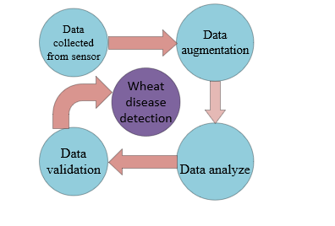

Figure 3: Data flow diagram

Our proposed methodology diagram is
We collected the image data which collected from the field. The next step is to preprocess the data. We divided data into the test set and train set. Then we apply a machine-learning algorithm to detect our results. After that, we apply different validation techniques to find out whether our results are good or not.
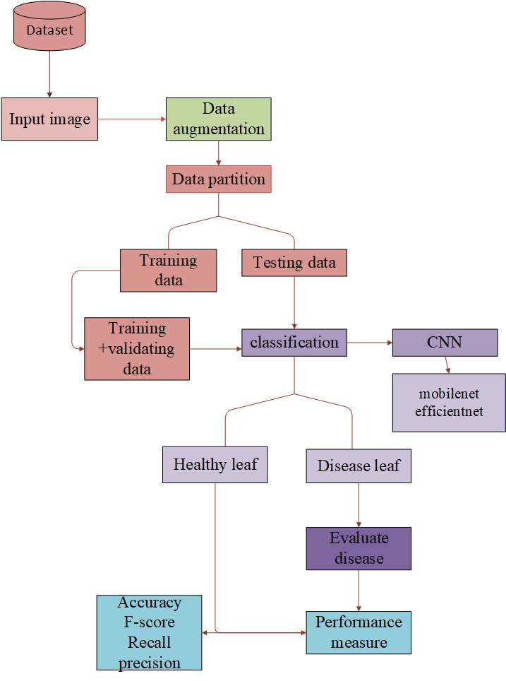

Figure 4: Methodology diagram

STEP1. Image dataset
Image datasets were collected from the Kaggle website. The dataset contains wheat leaf disease images. Dataset has 3types of images: healthy, septoria, and stripe rust. Dataset collected from Kaggle dataset.

STEP2. Prepare data
After uploading the dataset, we prepare the data. We create data frames of all images in three groups.

STEP3. Train, test, and validate data
The datasets were divided into two groups for machine learning. The first subset, referred to as the training data, is a section of our actual dataset that is used to train a machine learning model. The testing data refers to the other subset. Usually, training data is larger than testing data. This is because we want to provide the model with as much information as we can for it to identify and learn useful patterns. When our dataset’s data are supplied to a machine learning algorithm, the program recognizes patterns in the data and concludes.
The images were divided into three subsamples for machine learning: training (80%) images, validation (10%) images for selecting the best model during training, and test/hold out (10%) images to evaluate the correctness of the selected model. The iterative train test divide () method of the model selection Python module of the Detailed version library was used to construct the iterative segmentation strategy to ensure a fair distribution of multilevel classes in each subsample.
Two main standards apply when testing data. It ought to:
- Display the actual dataset
- Be am utilized to produce accurate predictions
This dataset must contain brand-new, "unseen," data, as we mentioned before.
Data preprocessing
Pre-processing is the term that describes the adjustments done to our data before we submit it to the algorithm. A technique for turning filthy data into clean data sets is data preparation. In other words, if data are gathered from numerous sources, they are done so in a way that prevents analysis.
Data preparation is a crucial requirement for any successful machine learning model. Preprocessing data means using the information in a way that the machine learning model can easily understand it.
Data augmentation
By creating a changed image version in the dataset, data augmentation is utilized to artificially enhance the training dataset. The amount of data used to train a utilized model will have a significant impact on its accuracy; the more data used, the more effective the model will be at making predictions. The methods used for data augmentation provide numerous variations of the same image, which increases the model's capacity to transfer its knowledge to new images. When a model is overfitting because there aren't enough training samples, the technique of data augmentation is frequently applied.
We apply CNN model to increase our model accuracy and better results. We apply mobilenet and efficient net to perform disease detection and performance measure.
MobileNet-v2 is a convolutional neural network that is 53 layers deep. You can load a pre-trained version of the network trained on more than a million images from the ImageNet database.
Using a compound coefficient, the convolutional neural network construction and scaling method EfficientNet uniformly scales all depth, breadth, and resolution dimensions. In contrast to conventional practice, which scales these variables freely, the EfficientNet scaling method uses a set of predetermined scaling coefficients to uniformly scale network breadth, depth, and resolution. Using times more computing power, for example, we might easily increase the network depth, width, and picture size, where and are constant coefficients discovered via a smaller grid search on the initial small model. To scale the network's width, depth, and resolution evenly, Efficient Net employs a compound coefficient[25].

RESULTS AND DISCUSSION
Model results using mobilenet
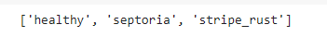
we display some images with different classes for example
we display images either affected images or healthy images
show disease images as sample

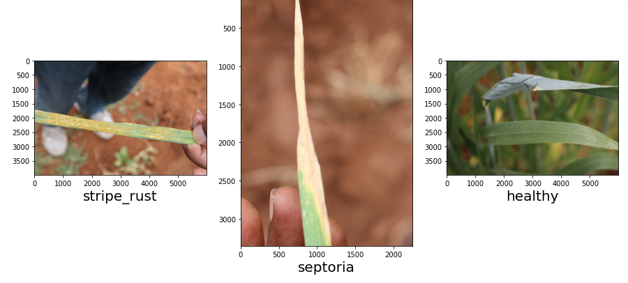
Figure 5:Healthy and Disease leaf images
Image augmentation
Image augmentation is a method of modifying the current data to produce more data for the model training procedure. In other words, it is the process of enhancing the dataset that is made available for deep learning model training. Image data augmentation is a technique for inflating the size of a training dataset by producing altered versions of the dataset's original images. By training deep learning neural network models on more data, fit models' capacity to generalize what they have learned to new images can be enhanced. The visuals can also be aall generalizeaugmentation telearnedes. The Keras deep learning neural network library provides the ability to fit models with the addition of image data via the Image Data Generator class.

An image to test transformation

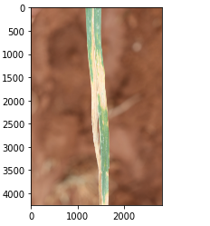

Figure 6: image augmentation

Test the transformation method
Image must be changed each time when the augmentation is applied

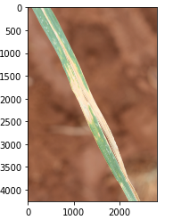

Figure 7: image augmentation from the test set

Train images that have been augmented

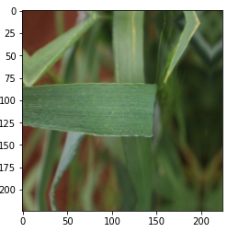

Figure 8: image augmentation from the test set

Print image from the validation set
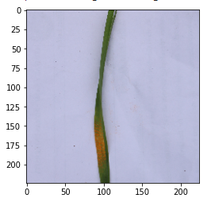

Figure 9: image augmentation from the validation set

Test images that have been augmented
Figure 10: image augmentation from the test set

Training and validation loss

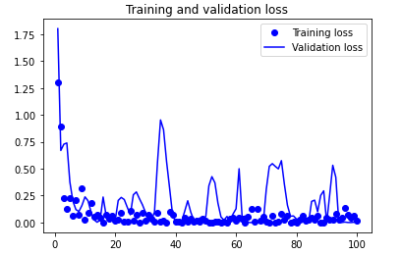

Figure 11: Training and validation loss graph
Training and validation accuracy

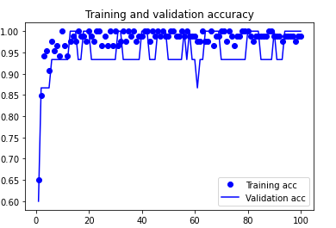

Figure 12: Training and validating accuracy graph

Confusion Matrix
The effectiveness of a classification model is evaluated using a N x N matrix known as a confusion matrix, where N is the total number of target classes. The machine learning model's predicted goal values are compared to the actual goal values in the matrix. This helps us gain a thorough grasp of the efficiency of our classification model as well as the kinds of errors it generates.
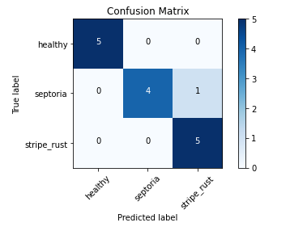
Figure 13: confusion matrix for mobile net

Precision |  | Recall | F1-score | Support
Healthy | 1.00 | 1.00 | 1.00 | 5
Septoria | 1.00 | 0.80 | 1.00 | 5
Stripe rust | 0.83 | 1.00 | 0.95 | 5
Accuracy |  |  | 0.97 | 15
Macro avg | 0.94 | 0.93 | 0.94 | 15
Weighted avg | 0.94 | 0.93 | 1.00 | 15

Model results using efficient net-b3
Training and validating loss

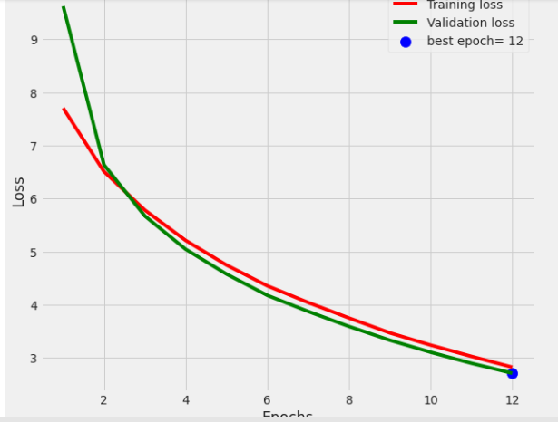

Figure 14: training and validating loss for efficient net

Training and validating accuracy

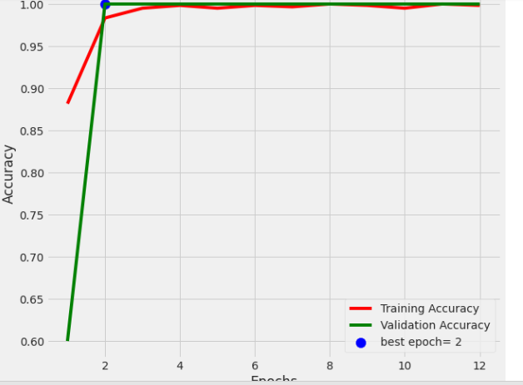

Figure 15: training and validating accuracy

Confusion matrix

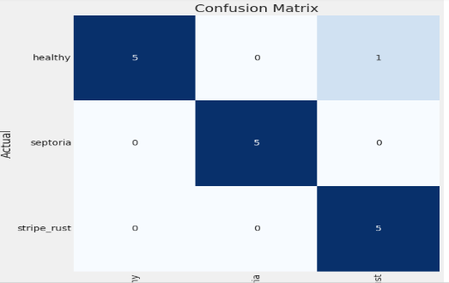

Figure 15: Confusion matrix efficient net

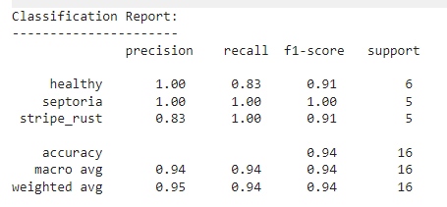

Table 2: comparing results between the proposed model
Model | precision | Recall | F1 score | Accuracy
moilenet | 1.0 | 0.8 | 1.0 | 0.97
Efficient net-b3 | 1.0 | 0.83 | 0.91 | 0.94

In our proposed model mobilenet give better accuracy as compared to efficient net.

Table 3: comparison of results with the previous paper
Reference | Model Name
 | Mobilenet | Efficientnet
[25] | 87% | -----
[26] | 90% | -----
[23] | ----- | 93%
Proposed work | 97% | 94%

CONCLUION
This paper demonstrated deep neural network leaf disease detection in wheat crops. We also do a complete overview by using a machine learning algorithm using IoT. To recognize disease leaves, other data enrichment and data preparation techniques are also applied. Since the severity of plant diseases varies over time, DL models should be enhanced or updated to allow them to identify and categorize diseases during their entire cycle of occurrence. The signatures created by the convolution neural network mobilenet, and efficient net improve the information carriers of the extracted stunning image. The suggested strategy improves accuracy and yields impressive results in the majority of wheat disease leaves
In the future, the datasets should contain images collected in a variety of field circumstances in addition to representing the real environment because the DL model/architecture should be effective under various lighting conditions. More and more real-time sensor-timed for soil management, temperature, and weather forecasting for improving wheat yield management.

REFERENCE
[1] X. E. Pantazi, D. Moshou, T. Alexandridis, R. L. Whetton, and A. M. Mouazen, “Wheat yield prediction using machine learning and advanced sensing techniques,” Comput. Electron. Agric., vol. 121, pp. 57–65, 2016, doi: 10.1016/j.compag.2015.11.018.
[2] S. Liang et al., “No 主観的健康感を中心とした在宅高齢者における 健康関連指標に関する共分散構造分析Title,” Proc. Natl. Acad. Sci., vol. 3, no. 1, pp. 1–15, 2015, [Online]. Available: http://dx.doi.org/10.1016/j.bpj.2015.06.056%0Ahttps://academic.oup.com/bioinformatics/article-abstract/34/13/2201/4852827%0Ainternal-pdf://semisupervised-3254828305/semisupervised.ppt%0Ahttp://dx.doi.org/10.1016/j.str.2013.02.005%0Ahttp://dx.doi.org/10.10.
[3] Y. Tan et al., “Improving wheat grain yield via promotion of water and nitrogen utilization in arid areas,” Sci. Rep., vol. 11, no. 1, pp. 1–12, 2021, doi: 10.1038/s41598-021-92894-6.
[4] K. Kanwal, K. T. Ahmad, R. Khan, N. Alhusaini, and L. Jing, “Deep learning using isotroping, laplacing, eigenvalues interpolative binding, and convolved determinants with normed mapping for large-scale image retrieval,” Sensors (Switzerland), vol. 21, no. 4, pp. 1–39, 2021, doi: 10.3390/s21041139.
[5] B. M. UMER SAEED Sc Agri, “Yield Forecasting of Wheat (Triticum aestivum L.) for different Irrigation and Nitrogen Levels Using Simulations and Satellite Imagery,” 2017, [Online]. Available: http://prr.hec.gov.pk/jspui/bitstream/123456789/8385/1/Umer_Saeed_Agronomy_2017_HSR_UAF_22.11.2017.pdf.
[6] A. Qayyum, “Model Based Wheat Yield,” no. 02, 2011.
[7] B. Melissari, “Remote Sensing Applications in Precision Agriculture Aplicaciones de Sensores Remotos en Agricultura de Precisión,” no. November, 2018.
[8] P. J. Pinter, J. L. Hatfield, and E. M. Barnes, “DigitalCommons @ University of Nebraska - Lincoln Remote Sensing for Crop Management,” 2003.
[9] E. Said Mohamed, A. A. Belal, S. Kotb Abd-Elmabod, M. A. El-Shirbeny, A. Gad, and M. B. Zahran, “Smart farming for improving agricultural management,” Egypt. J. Remote Sens. Sp. Sci., vol. 24, no. 3, pp. 971–981, 2021, doi: 10.1016/j.ejrs.2021.08.007.
[10] R. Akhter and S. A. Sofi, “Precision agriculture using IoT data analytics and machine learning,” J. King Saud Univ. - Comput. Inf. Sci., no. xxxx, 2021, doi: 10.1016/j.jksuci.2021.05.013.
[11] V. N. D. Prasanna, “<A Novel IOT Based Solution for Agriculture.pdf>,” Peer Rev. J., vol. 8, no. 1, January 2019, p. 3, 2019, doi: 10.15680/IJIRSET.2019.0801034.
[12] K. Bakthavatchalam et al., “IoT Framework for Measurement and Precision Agriculture: Predicting the Crop Using Machine Learning Algorithms,” Technologies, vol. 10, no. 1, p. 13, 2022, doi: 10.3390/technologies10010013.
[13] A. Patel, K. Pandey, H. Yadav, and P. Saraswat, “IOT Based System for Crop Prediction and Irrigation Control,” 2021 IEEE 8th Uttar Pradesh Sect. Int. Conf. Electr. Electron. Comput. Eng. UPCON 2021, vol. 10, no. 7, pp. 122–127, 2021, doi: 10.1109/UPCON52273.2021.9667576.
[14] K. N.-A. Siddiquee et al., “Development of Algorithms for an IoT-Based Smart Agriculture Monitoring System,” Wirel. Commun. Mob. Comput., vol. 2022, pp. 1–16, 2022, doi: 10.1155/2022/7372053.
[15] A. Ikram et al., “Crop Yield Maximization Using an IoT-Based Smart Decision,” vol. 2022, 2022.
[16] K. Phasinam, T. Kassanuk, and M. Shabaz, “Applicability of Internet of Things in Smart Farming,” J. Food Qual., vol. 2022, 2022, doi: 10.1155/2022/7692922.
[17] K. Alibabaei, P. D. Gaspar, and T. M. Lima, “Crop yield estimation using deep learning based on climate big data and irrigation scheduling,” Energies, vol. 14, no. 11, pp. 1–21, 2021, doi: 10.3390/en14113004.
[18] H. M. Al-Ghobari, F. S. Mohammad, and M. S. A. El Marazky, “Effect of intelligent irrigation on water use efficiency of wheat crop in arid region,” J. Anim. Plant Sci., vol. 23, no. 6, pp. 1691–1699, 2013.
[19] A. Mostafaeipour et al., “Machine learning for prediction of energy in wheat production,” Agric., vol. 10, no. 11, pp. 1–18, 2020, doi: 10.3390/agriculture10110517.
[20] N. Ejaz and S. Abbasi, “Wheat Yield Prediction Using Neural Network and Integrated SVM-NN with Regression,” … J. Eng. Technol. …, vol. 8, no. 2, pp. 77–97, 2020, [Online]. Available: https://journals.iobmresearch.com/index.php/PJETS/article/view/2231.
[21] S. A. Haider et al., “LSTM neural network based forecasting model for wheat production in Pakistan,” Agronomy, vol. 9, no. 2, pp. 1–12, 2019, doi: 10.3390/agronomy9020072.
[22] L. Benos, A. C. Tagarakis, G. Dolias, R. Berruto, D. Kateris, and D. Bochtis, “Machine learning in agriculture: A comprehensive updated review,” Sensors, vol. 21, no. 11, pp. 1–55, 2021, doi: 10.3390/s21113758.
[23] M. A. Genaev, E. S. Skolotneva, E. I. Gultyaeva, E. A. Orlova, N. P. Bechtold, and D. A. Afonnikov, “Image-based wheat fungi diseases identification by deep learning,” Plants, vol. 10, no. 8, 2021, doi: 10.3390/plants10081500.
[24] F. Abbas, H. Afzaal, A. A. Farooque, and S. Tang, “Crop yield prediction through proximal sensing and machine learning algorithms,” Agronomy, vol. 10, no. 7, 2020, doi: 10.3390/AGRONOMY10071046.
[25] F. Photographs et al., “Evaluation of Diverse Convolutional Neural Networks and Training Strategies for Wheat Leaf Disease Identification with,” 2022.
[26] S. Z. M. Zaki, M. A. Zulkifley, M. Mohd Stofa, N. A. M. Kamari, and N. A. Mohamed, “Classification of tomato leaf diseases using mobilenet v2,” IAES Int. J. Artif. Intell., vol. 9, no. 2, pp. 290–296, 2020, doi: 10.11591/ijai.v9.i2.pp290-296.

Figure 16. New time Roman Font 9

